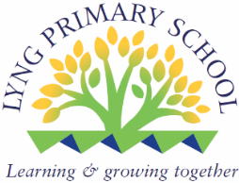

Mental Health and Emotional Wellbeing
Policy

Date Prepared: September 2022
Date Approved by Governing Body: July 2022
Date to be reviewed: September 2025

Chair of Governors _______________________________ Date_______________________

This policy was written in consultation with staff, pupils, parents and professionals involved in mental health and wellbeing.
Mission Statement
At Lyng Primary School we are committed to supporting the emotional health and wellbeing of our staff, children and families.
By spotting the signs of ill health early, we can cultivate and grow hope for recovery. Especially when early intervention is important by listening without judgement, we can grow the hope that someone who may be struggling with difficult experiences can feel accepted and understood.
We take the view that positive mental health is everyone’s responsibility and that we all have a role to play.
At our school we:
- help children to understand their emotions and feelings better
- help children feel comfortable sharing any concerns or worries
- help children socially to form and maintain relationships.
- promote self esteem and ensure children know that they count.
- encourage children to be confident and ‘dare to be different’
- help children to develop emotional resilience and to manage setbacks.
We promote a mentally healthy environment through:
- Promoting our school values and encouraging a sense of belonging.
- Promoting pupil voice and opportunities to participate in decision-making
- Celebrating academic and non-academic achievements
- Providing opportunities to develop a sense of worth through taking responsibility for themselves and others
- Providing opportunities to reflect.
- Access to appropriate support that meets their needs
We pursue our aims through:
- Universal, whole school approaches
- Support for pupils going through recent difficulties including bereavement.
- Specialised, targeted approaches aimed at pupils with more complex or long term difficulties including attachment disorder.

Scope
This policy should be read in conjunction with our SEND policy in cases where pupils mental health needs overlap with these. This policy should also be read in conjunction with policies for Behaviour and Anti-bullying, PSHE, RHE and SEMH. It should also sit alongside child protection procedures.

Lead Members of Staff
Whilst all staff have a responsibility to promote the mental health of students, staff with a specific, relevant remit include:
Mrs Wellings – DSL/SMHL
Mr Boughey – SEMH Lead/Learning Mentor

Miss Hartshorne – SENCO

Teaching about Mental Health Wave 1 Appendix 2
The skills, knowledge and understanding needed by our students to keep themselves mentally healthy and safe are included as part of our developmental PSHE, RHE curriculum.
Commando Joe (+Tracker)
RSHE/PSHE Jigsaw Curriculum
Chico Time
LOTC
Edible Gardens
Forest School
Safe and calm environment
Mindfulness
Dog, Duck and Cat
SDQ’s
Reflection area
Play Leaders
School Council
Positive Classroom Management
Caught being kind in class
Newsletter
National Online safety and The Connected World curriculum

The specific content of lessons will be determined by the specific needs of the cohort we’re teaching but we will also use Jigsaw curriculum frame work to ensure that we teach mental health and emotional wellbeing issues in a safe and sensitive manner.

Targeted support Wave 2
The school will offer support through targeted approaches for individual pupils or groups of pupils which may include:
Peer Mentors
Learning Mentor Support
Anger Management Intervention
Conflict Resolution Intervention
Worry boxes
Healthy Mind Happy Me
Nurture
Child line
Resilience Intervention
3 Houses/Wishes and Feelings
Bereavement
Young Minds
Lego Therapy
My Star
Draw and Talk
Boxall Profile
National Online safety
Targeted SDQ Intervention

The school will make use of resources to assess and track wellbeing as appropriate including:
- Strengths and Difficulties questionnaire
- The Boxall Profile

Signposting Wave 3
We will ensure that staff, pupils and parents are aware of what support is available within our school and how to access further support.

Please see Appendix 1 for child pathway

Identifying needs and Warning Signs
All staff will monitor pupils and report on Cpoms, identifying a range of possible difficulties including:
- Attendance
- Punctuality
- Relationships
- Approach to learning
- Physical indicators
- Negative behaviour patterns
- Family circumstances
- Recent bereavement
- Health indicators
School staff may also become aware of warning signs which indicate a student is experiencing mental health or emotional wellbeing issues. These warning signs should always be taken seriously and staff observing any of these warning signs should communicate their concerns with the Senior Mental Health Leads. SEMH Lead as appropriate.
Possible warning signs include:
- Changes in eating / sleeping habits
- Becoming socially withdrawn
- Changes in activity and mood
- Talking or joking about self-harm or suicide
- Expressing feelings of failure, uselessness or loss of hope
- Repeated physical pain or nausea with no evident cause
- An increase in lateness or absenteeism

Working with Parents
In order to support parents we will:
- Highlight sources of information and support about mental health and emotional wellbeing on our school website
- Share and allow parents to access sources of further support e.g. through parent forums Class Dojo.
- Ensure that all parents are aware of who to talk to, and how to get about this, if they have concerns about their child.
- Make our emotional wellbeing and mental health policy easily accessible to parents
- Share ideas about how parents can support positive mental health in their children.
- Keep parents informed about the mental health topics their children are learning about in PSHE, RHE and share ideas for extending and exploring this learning at home.

Working with other agencies and partners
As part of our targeted provision the school will work with other agencies to support children’s emotional health and wellbeing including:
Kooth
Murray Hall
Kaleidoscope
Point of Access
GP
A+E
School Nurse
CAMHS
Edward Trust (Bereavement)
Inclusion Support (SEMH)
Barnardos

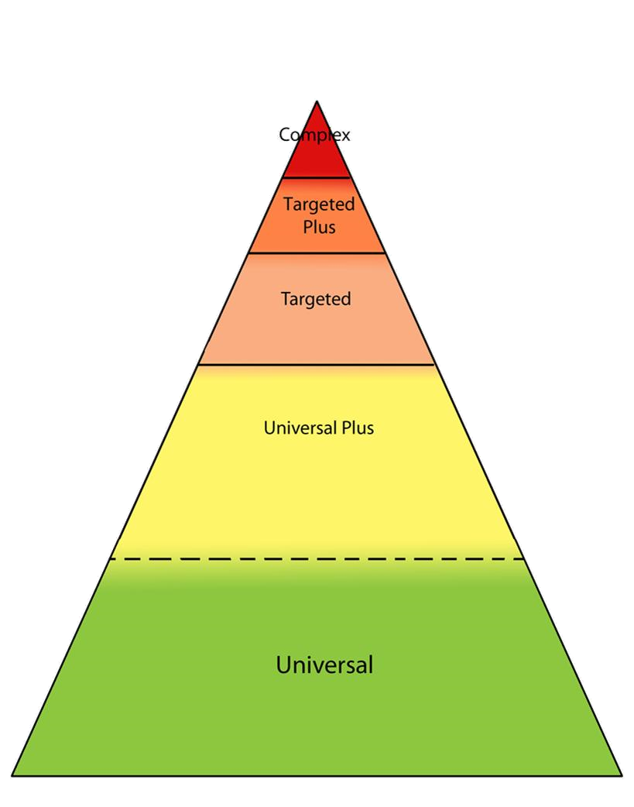
Safeguarding and Medical Intervention
Wave 4

Wave -3 External Support and safeguarding

Wave 2-3

Learning Mentor – Nurture

Wave 2 Learning Mentor group/1-1 sessions
Wave 1 Teaching and Learning

Training
As a minimum, all staff will receive regular training about recognising and responding to mental health issues.
The MindEd learning portal provides free online training suitable for staff wishing to know more about a specific issue.
Training opportunities for staff who require more in depth knowledge will be considered as part of our performance management process and additional CPD will be supported throughout the year where it becomes appropriate due to developing situations with one or more pupils.


Appendix 1
Mental Health and Wellbeing Support In My School
Wave 3
I may need a person outside of school who can help with my mental wellbeing and emotions because of something that may have happened to me or my family or I may find managing my emotions difficult
Mrs Wellings Will arrange this for me, they may have to make sure I am safe too and will speak to my teachers, parent/carers and me. The adults around me may have to put a plan together to make sure I am safe because I am finding my behaviour and emotions hard to manage .

Wave 2
If I need a little more help with my Mental Wellbeing I can see staff in school who will help me:
Mr Boughey, Mrs Wellings, Miss Parveen, Mrs Howard
I may have interventions in learning how to manage my emotions and behaviour. These adults will also speak to my Parents/carers
My Parents/carers can contact these adults and my class teacher if they feel I may need a little more help with my emotions
We also have Peer Mentor who are trained to support me if I am worried about anything

Wave 1
In school we learn to take care of our mental wellbeing by:
Our PSHE Lessons planned by our class teacher
Chico Time, this is when I can share with my teacher and my class what is going well for me and if I am worried about anything, We also talk about what's happening in the world
We learn outside which includes: Edible Garden s, Forest School, we know is good for our wellbeing
Our School is Safe and calm environment, we learn
Mindfulness and use the reflection table to help us understand how we are feelings when we are struggling
I talk to a trusted adult
SDQ’s Reflection area
Play Leaders
School Council
Positive Classroom Management
Caught being kind in class Newsletter

Appendix 2
Lyng Primary School
Mental Health Waves of Support for children

Access to specialist support
Wave 1
Commando Joe (+Tracker) Respect Curriculum
RSHE/PSHE Jigsaw Curriculum
Chico Time LOTC Edible Gardens Forest School
Safe and calm environment
Mindfulness Dog, Duck and Cat, PE, Swimming
SDQ’s Reflection area
Play Leaders, Broad and balanced curriculum, Trips
School Council
Positive Classroom Management
Caught being kind in class Newsletter

Wave 2
Peer Mentors
Learning Mentor Support
Anger Management Intervention
Conflict Resolution Intervention
Worry boxes Healthy Mind Happy Me
Nurture Child line
Resilience Intervention
3 Houses/Wishes and Feelings
Bereavement Young Minds
Lego Therapy My Star
Draw and Talk
Boxall Profile NOS
Targeted SDQ Intervention

Wave 3
Kooth
Murray Hall
Kaleidoscope
Point of Access
GP
A+E
School Nurse
CAMHS
Edward Trust (Bereavement)
Inclusion Support (SEMH)

Prevention

Identification
and Early Support

